 | 7 Demonstration Park, Sampleton  purchasing@merrowvale.example  https://merrowvale.example

Workplace supplies catalogue
Merrowvale Workplace Catalogue 2026 · Prices per pack, excluding VAT

Everyday essentials for offices, studios and archives, grouped by range. Quote the product code when you order.
  AT A GLANCE
  15 products
  in 3 ranges

 | Product | Code | Price excl. VAT | Price incl. VAT
Desk and organisation
 | Desk lamp, LED  Dimmable, USB-C charging port | MV-DK-LAM | £34.00 | £40.80
 | Desk organiser, bamboo  Five compartments | MV-DK-ORG | £22.00 | £26.40
 | Letter trays, stackable 3  Recycled plastic, charcoal | MV-DK-TRY | £14.20 | £17.04
 | Lever arch files, 10 pack  A4, 75 mm spine, recycled board | MV-DK-FIL | £19.50 | £23.40
 | Stapler, full strip  Up to 25 sheets, metal body | MV-DK-STP | £12.75 | £15.30
Paper and notebooks
 | A4 copier paper, 5 reams  80 gsm, FSC certified | MV-PP-A4W | £21.00 | £25.20
 | A4 ruled notebook, 5 pack  80 gsm, 160 pages, card cover | MV-NB-A4R | £11.50 | £13.80
 | A5 dotted journal  100 gsm, lay-flat binding | MV-NB-A5D | £8.95 | £10.74
 | Recycled envelopes C5, 500  Self-seal, 100% recycled | MV-NB-REC | £24.75 | £29.70
 | Sticky notes, 12 pads  76 × 76 mm, assorted pastels | MV-NB-STK | £6.40 | £7.68
Writing instruments
 | Fineliners, 10 colours  0.4 mm, water-based ink | MV-WR-FIN | £9.80 | £11.76
 | Fountain pen, steel nib  Refillable, medium nib | MV-WR-PEN | £18.00 | £21.60
 | Gel pens, black, 12 pack  0.7 mm, retractable | MV-WR-GEL | £7.20 | £8.64
 | Highlighters, 6 pack  Chisel tip, pastel shades | MV-WR-HIL | £5.60 | £6.72
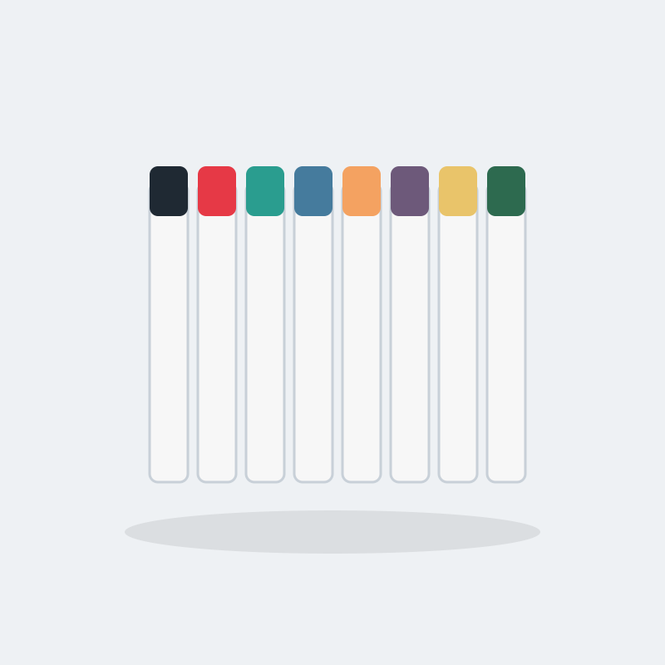 | Whiteboard markers, 8 pack  Low odour, dry wipe | MV-WR-MRK | £7.90 | £9.48

HOW TO ORDER
Email purchasing@merrowvale.example with the product codes and quantities you need, or ask your account manager.
Prices are per pack and exclude VAT and delivery. The price you pay is confirmed on your order acknowledgement.
This catalogue shows prices from the Merrowvale Workplace Catalogue 2026 price list on the date it was printed.

