INVOICE · AV-INV-10482  Invoice  Thank you for shopping with Aurevia
  BILL TO
  The Linden Room Interiors Ltd
  Amara Okoye
  14 Milsom Lane
  Bath
  BA1 1DN
  United Kingdom
  Invoice date | 2 October 2026
  Due date | On receipt
  Customer PO | LR-PO-3317
  VAT / Tax ID | GB999999973
  AMOUNT DUE
  £2,646.72

 | Item | Qty | Unit price | Discount | Line total
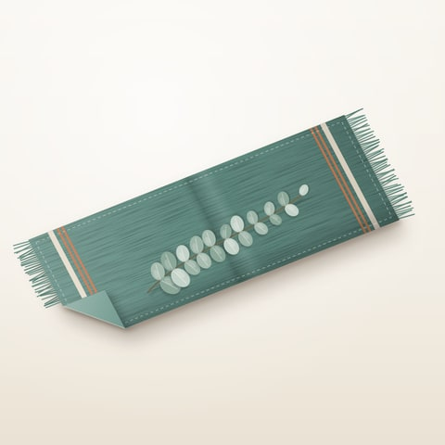 | Linen table runner, sage  AV-L210 · Stonewashed European linen · 40 × 220 cm | 12 | £38.00 | £0.00 | £456.00
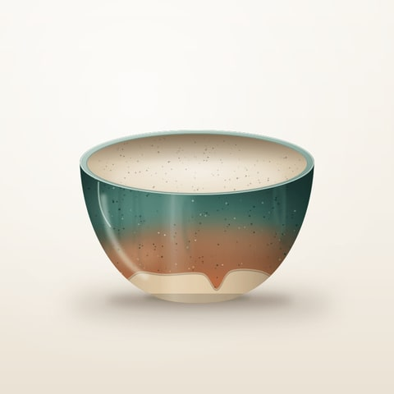 | Stoneware serving bowl  AV-C118 · Reactive glaze, hand-thrown · 28 cm | 8 | £46.00 | £0.00 | £368.00
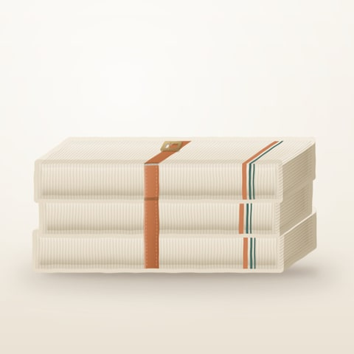 | Merino wool throw, oat  AV-T332 · 10% trade discount | 6 | £129.00 | £77.40 | £696.60
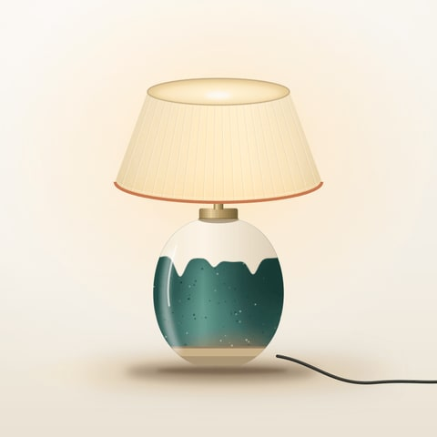 | Ceramic table lamp  AV-L045 · Matte clay base with linen shade · 52 cm | 4 | £165.00 | £0.00 | £660.00
 | Home delivery  AV-D010 · Two-person delivery, mainland UK | 1 | £25.00 | £0.00 | £25.00

PAYMENT  Please pay £2,646.72 on receipt, quoting invoice AV-INV-10482. Questions about this invoice: accounts@aurevia.example.  NOTES  Autumn restock for the Milsom Lane showroom.
  Thank you for your order. Care cards for each piece are packed with the delivery.
  Subtotal before discount | £2,283.00
  Discount | −£77.40
  Subtotal after discount | £2,205.60
  VAT | £441.12
  Grand total | £2,646.72
  Amount due £2,646.72

