QUOTATION · FF-Q-0284  Brewhouse cooling loop upgrade  Prepared for Harrowgate Brewing Co. Ltd  Second cooling loop for the brewhouse: heat exchanger, pump, actuated valves and a control panel with remote monitoring, supplied as one package with the installation kit.
  Issue date | 5 Oct 2026
  Valid until | 30 Nov 2026
  Quotation | FF-Q-0284

CUSTOMER  Harrowgate Brewing Co. Ltd  Eleanor Marsh  Unit 4, Kingsmead Business Park  Harrogate  HG1 4QR  United Kingdom | PROJECT  Kingsmead Brewhouse  Customer reference: HB-CAPEX-0412 | YOUR CONTACT  ForgeFlow  sales@forgeflow.example  +44 20 7946 0742

 | Item | Lead time | Qty | Unit price | Total
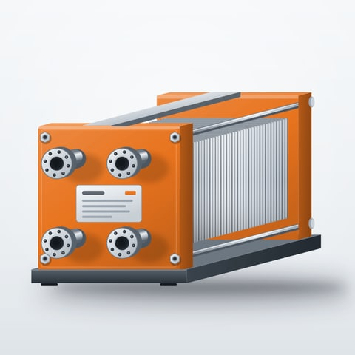 | Plate heat exchanger PHE-210  FF-HX210 · Stainless steel plates, EPDM gaskets · 210 kW duty | 4 weeks | 1 | £8,650.00 | £8,650.00
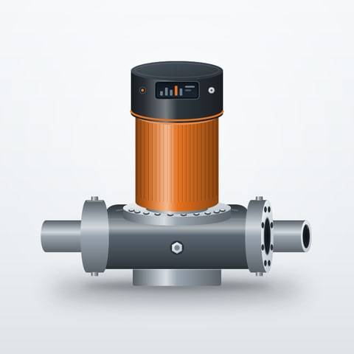 | Circulation pump CP-330  FF-P330 · Inline, IE4 motor · 4 kW | 3 weeks | 2 | £2,140.00 | £4,280.00
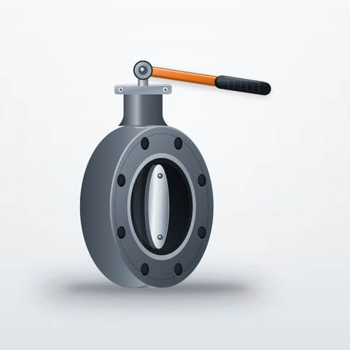 | Butterfly valve BV-115  FF-V115 · Lugged, actuated · DN80 | 2 weeks | 6 | £395.00 | £2,370.00
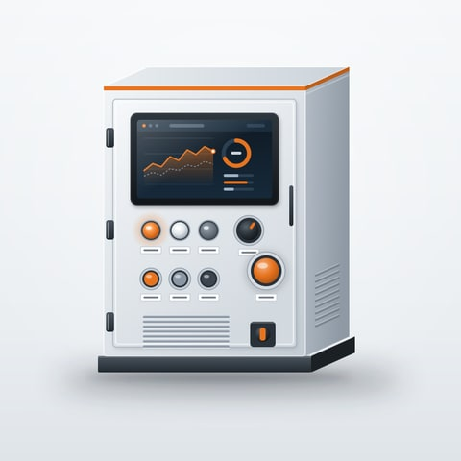 | Control panel CP-40  FF-C040 · PLC with 7-inch HMI and remote monitoring | 5 weeks | 1 | £5,280.00 | £5,280.00
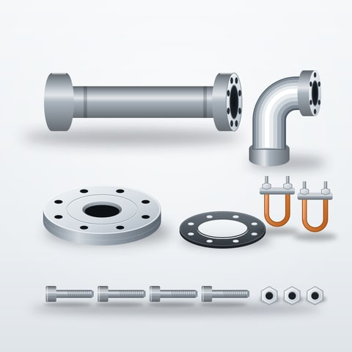 | Pipework installation kit  FF-S900 · Flanges, supports and fixings for one loop | To be confirmed | 1 | £1,175.00 | £1,175.00

  DEPOSIT
  A deposit of £7,993.80 (30%) is requested after acceptance. The balance of £18,652.20 is payable 30 days from the final invoice date.
  Subtotal | £21,755.00
  Freight | £450.00
  VAT | £4,441.00
  TOTAL | £26,646.00

QUOTATION · FF-Q-0284

Scope & terms

Scope of supply
Supply of the equipment and quantities listed on page 1, with standard protective packaging, product documentation and delivery to the named site. No substitute products will be supplied without agreement.

Commercial terms
Pricing  Firm until the quotation expires | Payment terms  30 days from invoice date | Freight  £450.00

Delivery schedule
Lead times on page 1 are estimates counted from the issue date and confirmed with the order acknowledgement. Items marked “To be confirmed” are scheduled once the fabricator confirms.

Assumptions & exclusions
The customer confirms connection sizes and site access before order acceptance. Installation, commissioning, civil works and removal of existing equipment are not included.

Warranty
Equipment carries the manufacturer’s standard two-year parts warranty from delivery, subject to installation and maintenance in line with the product documentation.

Cost breakdown
Family | Net amount
Process equipment | £12,930.00
Valves and fittings | £2,370.00
Controls | £5,280.00
Installation | £1,175.00

Net line amounts before freight and tax.

Acceptance
Please confirm the authorised signatory and purchase-order reference.
Accepted by | Position | Signature | Date

