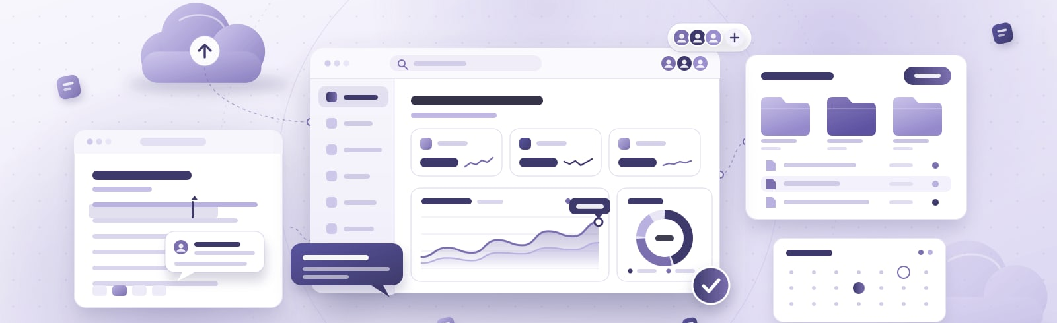
SERVICE AGREEMENT  VC-AGR-0441 Workspace subscription  Between Velmora Cloud Services Ltd and Nettlewick Group Ltd.
  Start date | 1 October 2026
  End date | 30 September 2027
  Term | 12 months
  Status | For signature

SUPPLIER  Velmora Cloud Services Ltd  25 Example Square, Sampleton  orders@velmora.example | CUSTOMER  Nettlewick Group Ltd.  2 Example Gardens  Sampleton  United Kingdom

KEY TERMS
Service start  1 October 2026 | Initial term  12 months, to 30 September 2027
Fees (Schedule 1)  £6,600.00 excluding VAT | Renewal  Renews automatically for 12 months
Renewal reminder  60 days before the end date | Payment terms  30 days from invoice date

Terms
- Agreement
  - This agreement is made between Velmora Cloud Services Ltd (the “Supplier”) and Nettlewick Group Ltd. (the “Customer”).
  - It starts on 1 October 2026 and continues for 12 months, ending on 30 September 2027, unless it is renewed under clause 4 or ended earlier under clause 7.
- Services
  - The Supplier will provide the subscription and one-off services listed in Schedule 1 from the start date, as described in the Supplier’s published service description.
- Fees and invoicing
  - The Customer will pay the fees in Schedule 1. Subscription fees are invoiced annually in advance; one-off services are invoiced when delivered.
  - Fees exclude VAT, which is added at the rate in force on the invoice date. Invoices are payable within 30 days of the invoice date.
- Renewal
  - This agreement renews automatically for a further 12 months at the end of each term unless either party gives written notice at least 60 days before the end date.
- Data protection
  - Each party will comply with the data protection law that applies to it. The Supplier processes customer data only to provide the services and on the Customer’s documented instructions.
- Confidentiality
  - Each party will keep the other’s confidential information confidential and use it only for the purposes of this agreement.
- Ending the agreement
  - Either party may end this agreement by written notice if the other party materially breaches it and does not remedy the breach within 30 days of being asked to.
- Special terms
  - Onboarding: two remote training sessions for up to ten administrators within 30 days of the start date. Data export on request at the end of the term, in CSV, at no charge.
- General
  - This agreement is governed by the law of England and Wales.

Schedule 1: Services and fees
Order VC-SO-0441 · Customer PO NW-2018 · ordered 24 September 2026
Service | Period | Qty | Unit price | Amount
Workspace subscription  Annual licence per user | 1 Oct 2026 – 30 Sep 2027 | 25 | £240.00 | £6,000.00
Administrator onboarding  One-off remote session | One-off · booked 5 Oct 2026 | 1 | £600.00 | £600.00

Subscription fees | £6,000.00
One-off services | £600.00
Total fees excl. VAT | £6,600.00

Signatures
Signed for and on behalf of each party. By signing, each party agrees to the terms of this agreement.
FOR VELMORA CLOUD SERVICES LTD  Signature  Name and position  Date | FOR NETTLEWICK GROUP LTD.  Signature  Name and position  Date

